CYBER SECURITY FOR BUSINESS: INDIVIDUAL PORTFOLIO
Table of Contents
Part 1: Authentication 4
Overview 4
Important Points of Attack in Authentication 4
Customer Authentication System 4
Methods for Creating and Resetting a Password 5
Internal Admin User Authentication 6
Summary 7
Part 2: System Security 8
Attack Vectors Applicable to Endpoints 8
Security Measures for Endpoint Protection 9
Processes to Follow in the Event of a Loss of an Employee Laptop 9
Pros and Cons of Provisioning Employees with Admin Access 10
Part 3: Security of Sensitive Data 11
a. Determine the reason for the app that collects sensitive data 11
b. key attack vectors applicable related to the storage of sensitive data 12
c. Steps to secure the personal data 12
d. Strategy for utilizing to store the information 13
Conclusion 14
Part 4: Payment Data on the Cloud 15
a. Types of Payment Data and Associated Risks 15
b. Collection and Storage of Payment Data 15
c. Obligations for Compliance 16
d. Crisis Management Procedures 16
Conclusion 17
References 18

Part 1: Authentication

Overview
When designing an e-commerce application, a cyber security architect must prioritise making sure that security is built in from the start. To guarantee the safety of the application, we'll examine the numerous authentication-related design options and provide suggestions.

Important Points of Attack in Authentication
A person, device, or system's authenticity may be established via a process known as "authentication." Security holes in the authentication procedure may be used by attackers to obtain unauthorised access to networks. As per the view of ALZAHRANI (2021), from an authentication point of view, the following attack vectors are most important to be aware of:
In order to obtain unauthorised access to a system, hackers may attempt to guess or break a user's password. Passwords may be stolen in many different ways by attackers. Common methods include brute force assaults, dictionary attacks, and phishing.
One kind of cyberattack is called "credential stuffing," it consists of an attacker using the stolen credentials of one website to gain access to another. As cited by BARNES (2018), when users have the same password for many accounts, this form of attack becomes feasible.
Man-in-the-middle (MITM) attacks happen when an attacker intercedes between a user and a service to get access to sensitive information. This method may be used by attackers to steal session cookies or login information.
The term "session hijacking" refers to an attack in which an attacker takes over the session of a legitimate user by obtaining their session cookie. As stated by GHADGE et al. (2021), several methods exist for attackers to steal session cookies, such as session fixation and session prediction.

Customer Authentication System
Customer authentication methods must be developed to restrict access to the e-commerce platform to approved users exclusively. These are the procedures you should take to authenticate a user:
Customer Account Creation: Before making a purchase, online storefront users must create a user account. Customers must provide their name, email address, and a robust password during registration.
Customers who sign up for an account should get an email with a verification link inside it. The customer's email address and account creation should be confirmed by clicking the verification link.
Customers should be compelled to implement two-factor authentication (2FA) to increase the security of the authentication process. As per the view of HACIOGLU and SEVGILIOGLU (2019), two-factor authentication (2FA) uses a second, independent method to confirm a user's claimed identity.
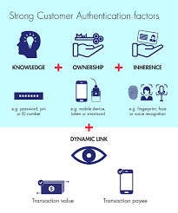
Figure 1: Customer authentication factors
(Source: HALIMA et al. 2018)
It is recommended that passwords be at least 8 characters long and include capital and lowercase letters, digits, and special characters. In order to avoid the usage of easily cracked passwords, it is recommended that users' choices be validated against a database of widely used passwords.

Methods for Creating and Resetting a Password
Only authorised users should be able to go through the steps of establishing a new password or resetting an existing one. The best practices for creating and resetting passwords are as follows:
Password complexity should be a requirement of the e-commerce platform. We recommend that passwords be at least 8 characters long and include capital, lowercase, numeric, and special characters.
Resetting a customer's password is as simple as entering their email address and a new password. After the user has successfully reset their password, the password reset link should no longer work.
It is recommended that two-factor authentication (2FA) be used to confirm a user's identity during the password reset process. You may use a different email address or cell phone for this.

Internal Admin User Authentication
The e-commerce platform allows internal admins to access the back end and set up the platform as needed. Authentication methods for internal administrative users should vary from those for external consumers. For internal administrative users, the suggested authentication procedures are as follows:
For internal administrative users, it is recommended to employ role-based access control (RBAC). Role-based access control, or RBAC, is a mechanism for limiting access to resources based on users' positions within an organisation. To ensure that internal administrative users only have access to the tools they need to do their jobs, responsibilities may be assigned to them.
Security-conscious passwords are those that are at least 12 characters long, utilise a mix of capital and lowercase letters, digits, and symbols, and are only known by the user. In order to avoid the usage of easily cracked passwords, it is recommended that users' choices be validated against a database of widely used passwords.
Implementing multi-factor authentication (MFA) is recommended to increase the safety of the authentication process for internal administrative users. As mentioned by HRISTEV and VESELINOVA (2021), two or more pieces of information are used to determine a person's identity in MFA. A mobile phone, security token, or biometric authentication may all be used for this purpose.
Internal administrative users should have privileged access management (PAM) in place. Privileged access management (PAM) is a system for managing and keeping tabs on elevated user privileges. PAM solutions may include things like session recording, password rotation, and just-in-time access.

Summary
The entire task has been summarised with the authentication is a must for protecting any online store. Security holes in the authentication procedure may be used by attackers to obtain unauthorised access to networks. Only authorised users should be able to access the e-commerce application, so it's important to implement strong password policies, multi-factor authentication, and role-based access control for both customers and internal administrative users.

Part 2: System Security
Any cyber security engineer needs to think about the security of endpoints like computers, servers, and other devices used by staff. As per the view of KRISHNA and SEBASTIAN (2021), cybercriminals often go after these sites to find weaknesses they can use to gain illegal entry to the network or steal sensitive information. To stop these kinds of threats, it is very important to set up security rules and processes.

Attack Vectors Applicable to Endpoints
Some important ways to attack destinations are:
Malware is bad software that can spread through infected email files, infected downloads, or apps that have been hacked. When hackers install malware, they can steal information or get into a system without permission.
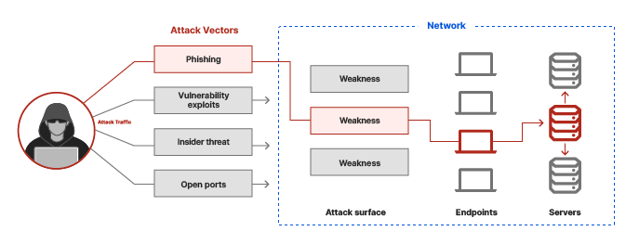
Figure 2: Network of attack vectors
(Source: NICOLAU et al. 2022)
Phishing emails, vishing (voice phishing) calls, and smishing (short messaging service (SMS) phishing) are all examples of social engineering attacks that try to trick people into giving out personal information or spreading malware.
Without the latest security fixes, the software can be used to attack both the endpoint and the company network.

Security Measures for Endpoint Protection
To protect endpoints from these kinds of risks, the following security steps should be taken:
Malware threats can be stopped by making sure all computers have protection and anti-malware software.
Set up a router to screen and look at the data coming into and going out of the location. Both the client and the company's network are safe from hacking this way.
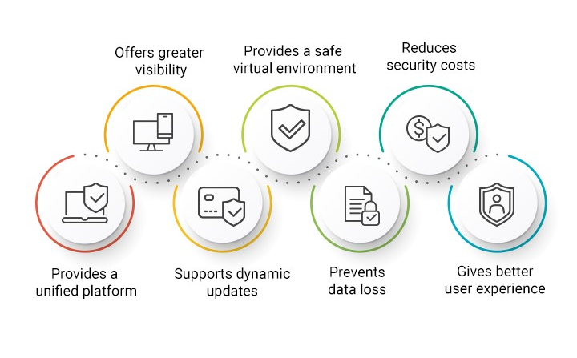
Figure 3: Benefits of endpoint security for enterprises
(Source: OYELAMI and AZLEENA, 2020)
A fixed control process should be in place for the software to make sure it always has the most recent security changes. So, bad people won't be able to use flaws that have already been found but haven't been fixed.
Employees should be taught how to recognise and fight back against social engineering. This may make it less likely that they will accidentally share personal information or download malware.

Processes to Follow in the Event of a Loss of an Employee Laptop
If an employee's laptop is stolen or lost, these steps should be taken:
Private information on the laptop can be deleted remotely so that it can't be seen by people who aren't supposed to. As per the view of RAWINDARAN et al. (2022), if the employee is to be held responsible, they should know what's going on and so should the right security staff. There needs to be a review to find out what happened and if any secret information was leaked. The pros and cons of giving employees administrative rights

Pros and Cons of Provisioning Employees with Admin Access
Employees can make changes to their system, like adding new software, without getting permission from IT first. Employees can get more done in less time without having to ask IT staff for help. Giving staff control access, on the other hand, has a number of cons, such as:
Endpoint and network security could be at risk if staff members make changes to their computers or install malware without meaning to. As stated by RAWINDARAN et al. (2021), allowing all workers to have management rights makes it more likely that laws that say only approved people can access certain data or systems will not be followed.
Summarizing the whole point, it is important to set up security policies and processes that protect computers from dangers like malware, social engineering, and old software that hasn't been updated. Also, there should be a plan for what to do if a laptop computer is lost, and the pros and cons of giving staff management rights should be carefully weighed.

Part 3: Security of Sensitive Data

a. Determine the reason for the app that collects sensitive data
Data components are classified as "sensitive" if their disclosure might cause physical or financial harm to a person or business. Some examples of potentially sensitive data that may be gathered by an e-commerce app are:
Data that may be used to uniquely identify an individual, including but not limited to name, address, phone number, email address, birth date, and government-issued ID. As illustrated by RENAUD and OPHOFF (2021), this data is gathered to ensure the customer's identity and to comply with government mandates requiring such verification.
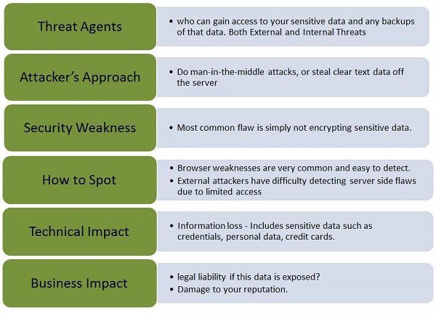
Figure 4: Sensitive data exposure
(Source: SHI et al. 2022)
Data relating to a person's financial situation, including credit card numbers, bank account information, and transaction history. This data is used for billing purposes and so that buyers may check their purchase history.
Past purchases, shopping habits, and product opinions may all be gleaned from a customer's order history. As illustrated by SKIBAN et al. (2023), customers' preferences are tracked so that they may get tailored suggestions and service enhancements.

b. key attack vectors applicable related to the storage of sensitive data
Important attack surfaces connected to sensitive data storage include:
By exploiting system flaws or guessing weak passwords, hackers may get access to private information without permission. Malware and ransomware are two types of cyberattacks in which sensitive information is either stolen from the system or encrypted and held hostage until a ransom is paid. Employees or contractors with access to sensitive data may improperly use or disclose the data, either on purpose or by accident.

c. Steps to secure the personal data
The following precautions should be taken to ensure the safety of any sensitive data collected:
Encryption: When transmitting or storing sensitive information, it is essential that it be encrypted to prevent unauthorised access.
Controlled access: Only authorised individuals who need access in order to do their jobs should have it. Strong passwords, multi-factor authentication, and role-based access limits may all help with this.
Data classification: Classifying data according to its sensitivity allows for more precise access restrictions to be implemented. As cited by TAM et al. (2021), credit card numbers, for instance, are examples of extremely sensitive data that should be restricted to a small group of employees.
Regular backups: To prevent data loss due to hardware failure or cyberattacks, it is important to create and store regular backups of critical information in a safe, offsite place.
Monitoring: When monitoring for suspicious behaviour or efforts to access private information, anomaly detection and monitoring technologies should be employed. With the use of these instruments, security professionals may be made aware of possible security breaches and act swiftly in response to them.

d. Strategy for utilizing to store the information
The retention of data is the time period over which information should be kept before being erased. The following criteria should be used to establish an adequate data retention period:
For reasons of law or regulation, it may be necessary to store certain kinds of data for a longer length of time than others.
Data retention policies should take into account the following business requirements: the need to maintain data for auditing, providing customer service, or resolving disputes.
For privacy reasons, data should be kept for no longer than is required to achieve the goals for which it was gathered.
Once the necessary data retention duration has been established, the following strategy may be implemented:
- Data retention policies should be evaluated on a regular basis to ensure that they continue to meet both legal and regulatory obligations, as well as the needs of the organisation.
- Data should be removed securely from all systems when the retention term has ended to avoid unauthorised access.
- Safely storing data means keeping it locked up for whatever length is required.
The information that keeps should be encrypted so that only authorised parties may access it. As cited by WANG et al. (2022), different kinds of encryption, such as symmetric key encryption and asymmetric key encryption and hashing, may accomplish the same goal.
Backups should be performed often to guarantee that data can be restored in the event of a system failure or data loss. The copies should be kept in a safe, off-site place.
Data masking is protecting personally identifiable information by hiding sensitive data like credit cards and social security numbers.
When the data retention term has ended, it must be deleted in a safe manner. Data shredding and data erasure are two methods that may help with this.
Note that data retention must be carried out in accordance with all relevant laws and regulations. In addition, businesses need to have a defined data retention and deletion policy and provide workers with enough training on the subject.

Conclusion
In conclusion, if you're a cybersecurity architect for a company that plans to release an e-commerce app, you should include security measures early in the design process to protect sensitive consumer information and boost sales. To do this, a holistic strategy for protecting sensitive data, systems, and identities is required. Organisations may safeguard sensitive data from a variety of threats and assure its safekeeping by applying the security measures discussed in this report.

Part 4: Payment Data on the Cloud

a. Types of Payment Data and Associated Risks
Payment information, such as credit card numbers, bank account numbers, and transaction details, may be gathered as part of the e-commerce application. As stated by YANG and YIN (2023), due to the potential for identity theft, financial fraud, and phishing assaults using this information, it must be kept secure.
Here are some of the main concerns with amassing financial information:
- Access denied Unauthorised parties might get access to sensitive payment information and perhaps utilise it for fraudulent purposes.
- Employees who have ill intentions and are authorised to access payment information pose a danger from the inside.
- Payment information may be taken in a data breach or cyber assault, causing serious problems for the company's finances and image.
- Failure to adhere to established norms and laws in any given field may result in financial fines, personal culpability, and a tarnished image.
It is assumed that a third-party payment processor will be used by the e-commerce app.

b. Collection and Storage of Payment Data
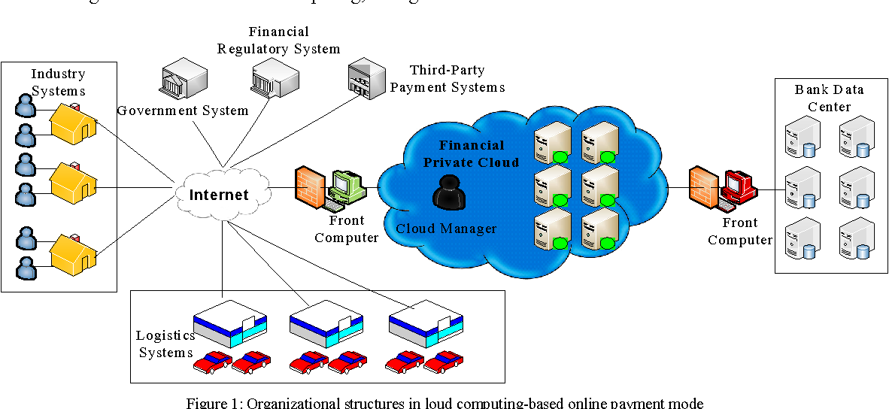
Figure 5: Cloud-based online computing method
(Source: ZEIJLEMAKER et al. 2022)
The following safeguards are recommended for the safe gathering and storage of financial information:
- The payment information should be encrypted both while in transit and while stored. Secure key management is essential, as it limits who may access the encryption keys.
- Tokenization entails the replacement of sensitive payment data with worthless tokens that cannot be utilised in fraud. In the event of a data breach, the potential for theft is mitigated.
- Implementing two-factor authentication may help guarantee that only approved individuals can access sensitive financial information.
- The payment information should be protected by access controls that adhere to the concept of least privilege. Employees who do not absolutely need access to execute their jobs should be denied access.
- Payment data storage and processing systems should be regularly audited and monitored to assist identify any suspicious actions.

c. Obligations for Compliance
The Payment Card Industry Data Security Standard (PCI DSS) is one such rule that businesses that deal with financial data must follow. As stated by ZWILLING (2022), encryption, restricted access, and constant monitoring and auditing are just some of the security measures that must be put in place to comply with PCI DSS.

d. Crisis Management Procedures
An incident response plan including the following procedures should be in place in the case of a security breach that affects payment data for the organisation:
- Breach identification: The organisation should have processes in place to detect and identify a security breach, as shown by the fact that the breach has been identified.
- Containment: The break must be contained immediately, and measures made to avoid future harm.
- Notification: In accordance with regulatory obligations, the relevant authorities and affected persons must be informed of the violation.
- Investigation: The company must investigate the breach thoroughly to learn what caused it and how extensive it is.
- Remediation: The breach must be fixed, and further attacks must be stopped, by taking corrective action.
The company has a backup and recovery strategy for financial data in the event of a catastrophe.

Conclusion
The entire task has been concluded that in order to protect the e-commerce application and its users from potential cyber assaults, it is crucial to implement appropriate security measures for authentication, system security, sensitive data, and payment data. Strict adherence to the standards and laws of one's industry is necessary for both maintaining confidence with one's customers and avoiding legal repercussions. To ensure the safety of the e-commerce application and its users, it is crucial for a cyber security expert to be aware of the latest threats and best practices. In order to avoid data theft and fraudulent actions, proper security rules must be implemented while collecting and storing payment data in an e-commerce application. Maintaining PCI DSS compliance and other industry standards is also crucial. Effectively dealing with security breaches requires the implementation of an incident response strategy.

References
ALZAHRANI, L., 2021. Statistical Analysis of Cybersecurity Awareness Issues in Higher Education Institutes. International Journal of Advanced Computer Science and Applications, 12(11),.
BARNES, I., 2018. Implementation of Active Cyber Defense Measures. Homeland Security Affairs, .
GHADGE, A., WEIß, M., CALDWELL, N.D. and WILDING, R., 2020. Managing cyber risk in supply chains: a review and research agenda. Supply Chain Management, 25(2), pp. 223-240.
HACIOGLU, U. and SEVGILIOGLU, G., 2019. The evolving role of automated systems and its cyber-security issue for global business operations in Industry 4.0. International Journal of Business Ecosystem & Strategy, 1(1), pp. 1-11.
HALIMA, I.K., ISLAM, S. and MOHAMMAD, A.R., 2018. An Integrated Cyber Security Risk Management Approach for a Cyber-Physical System. Applied Sciences, 8(6),.
HRISTEV, R. and VESELINOVA, M., 2021. ICT for Cyber Security in Business. IOP Conference Series.Materials Science and Engineering, 1099(1),.
KRISHNA, B. and SEBASTIAN, M.P., 2021. Examining the relationship between e-government development, nation’s cyber-security commitment, business usage and economic prosperity: a cross-country analysis. Information and Computer Security, 29(5), pp. 737-760.
NICOLAU, C., NICHIFOR, E., MUNTEANU, D. and BĂRBULESCU, O., 2022. Decoding Business Potential for Digital Sustainable Entrepreneurship: What Romanian Entrepreneurs Think and Do for the Future. Sustainability, 14(20), pp. 13636.
OYELAMI, J.O. and AZLEENA, M.K., 2020. Cyber Security Defence Policies: A Proposed Guidelines for Organisations Cyber Security Practices. International Journal of Advanced Computer Science and Applications, 11(8),.
RAWINDARAN, N., JAYAL, A. and PRAKASH, E., 2021. Machine Learning Cybersecurity Adoption in Small and Medium Enterprises in Developed Countries. Computers, 10(11), pp. 150.
RAWINDARAN, N., JAYAL, A. and PRAKASH, E., 2022. Exploration of the Impact of Cybersecurity Awareness on Small and Medium Enterprises (SMEs) in Wales Using Intelligent Software to Combat Cybercrime. Computers, 11(12), pp. 174.
RENAUD, K. and OPHOFF, J., 2021. A cyber situational awareness model to predict the implementation of cyber security controls and precautions by SMEs. Organizational Cybersecurity Journal: Practice, Process and People, 1(1), pp. 24-46.
SHI, L., YANG, M., LU, Y. and CHEN, L., 2022. The Application of Computer Intelligence in the Cyber-Physical Business System Integration in Network Security. Computational Intelligence and Neuroscience : CIN, 2022.
SKIBAN, O., KOSTETSKYI, Y., DANYLOVYCH-KROPYVNYTSKA, M., CHOLYSHKINA, O. and MIROSHNICHENKO, M., 2023. Formation of Business Cyber Security in Conditions of Instability of the Domestic Economy. Economic Affairs, 68(1), pp. 61-71.
TAM, T., RAO, A. and HALL, J., 2021. The good, the bad and the missing: A Narrative review of cyber-security implications for australian small businesses. Computers & Security, 109, pp. 1.
WANG, G., TSE, D., CUI, Y. and JIANG, H., 2022. An Exploratory Study on Sustaining Cyber Security Protection through SETA Implementation. Sustainability, 14(14), pp. 8319.
YANG, Y. and YIN, Z., 2023. Accountancy for E-Business Enterprises Based on Cyber Security. International Journal of Data Warehousing and Mining, 19(6), pp. 1-17.
ZEIJLEMAKER, S., ETIËNNE, A.J.A.R., CUNICO, G., ARMENIA, S. and MICHAEL, V.K., 2022. Decision-Makers’ Understanding of Cyber-Security’s Systemic and Dynamic Complexity: Insights from a Board Game for Bank Managers. Systems, 10(2), pp. 49.
ZWILLING, M., 2022. Trends and Challenges Regarding Cyber Risk Mitigation by CISOs—A Systematic Literature and Experts’ Opinion Review Based on Text Analytics. Sustainability, 14(3), pp. 1311.

